**Microprocessor and Computer Architecture**

**UE20CS252**

**4th Semester, Academic Year 2021-22**

Date:

|  |  |  |
| --- | --- | --- |
| Name: Naman Choudhary | SRN: PES2UG20CS209 | Section  D |

Week#____1_______ Program Number: ____1___

Title of the Program

**Write an ALP using ARM instruction set to check if a number stored in a register is even or odd. If even, store 00 in R0, else store FF in R0**

1. ARM Assembly Code(1)
2. .text
4. MOV r1, #3
5. ANDs r2, r1, #1

8. BEQ condition
9. MOV r0, #0xFF
10. B exit
11. condition:
12. MOV r0, #0x00
13. exit:
14. SWI 0x011
15. .end
16. Output Screen Shot (1)

The output should be verified for both even and odd numbers.

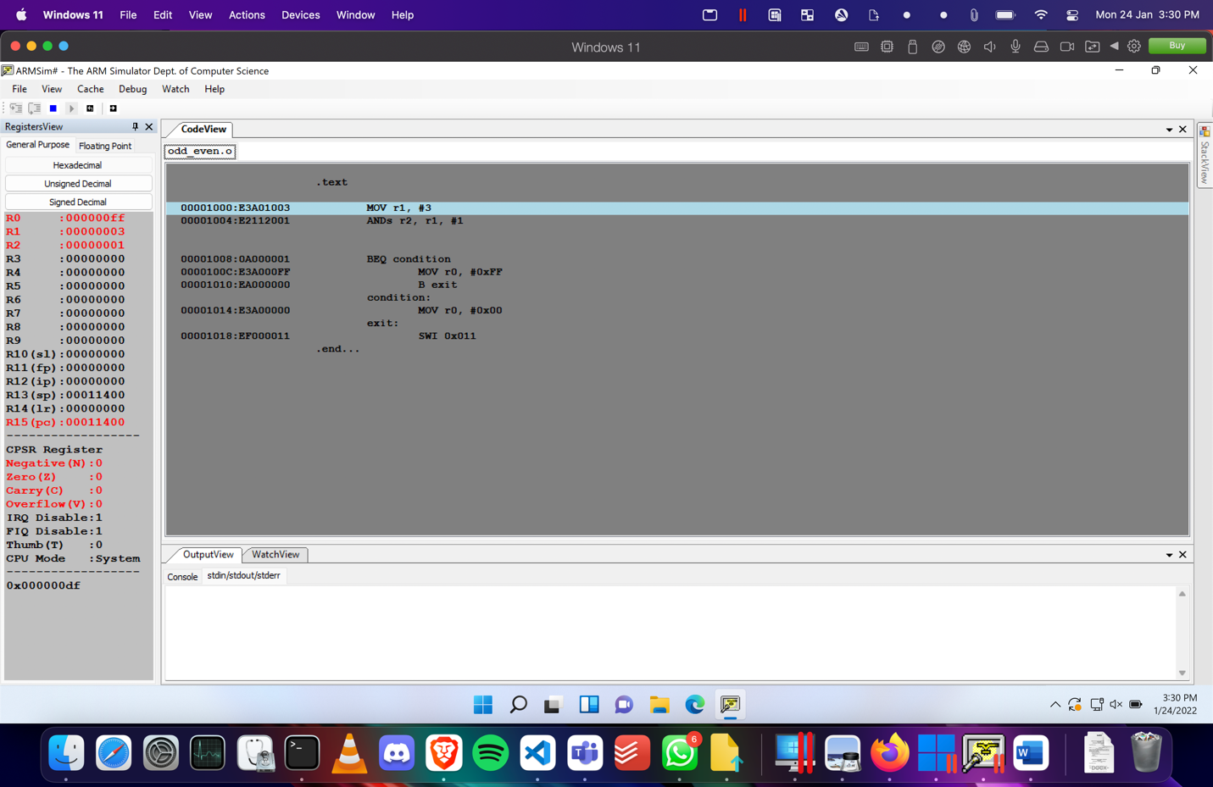Odd:

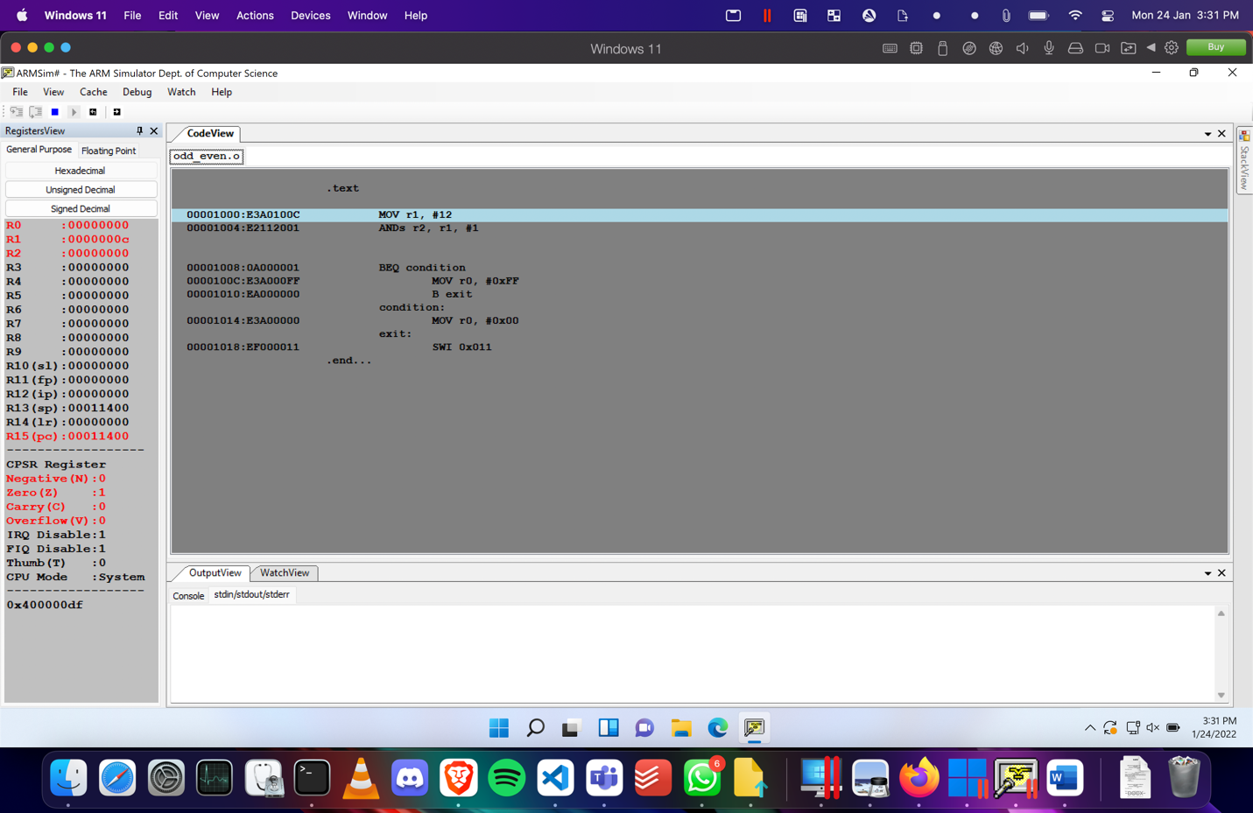Even:

1. Output table (1)

**Included in above screenshots**

**Microprocessor and Computer Architecture**

**UE20CS253**

**4th Semester, Academic Year 2021-22**

Date:

|  |  |  |
| --- | --- | --- |
| Name: Naman Choudhary | SRN:PES2UG20CS209 | Section  D |

Week#____1_______ Program Number: ____2___

Title of the Program

**Write an ALP to compare the value of R0 and R1, add if R0 = R1, else subtract**

1. ARM Assembly Code(1)

.text

MOV r0, #30

MOV r1, #10

SUBs r2, r0, r1

BEQ condition

SUB r3, r0, r1

B exit

condition:

ADD r3, r0, r1

exit:

SWI 0x011

.end

1. Output Screen Shot (1)

The output should be verified for both add and subracting numbers.

Add:

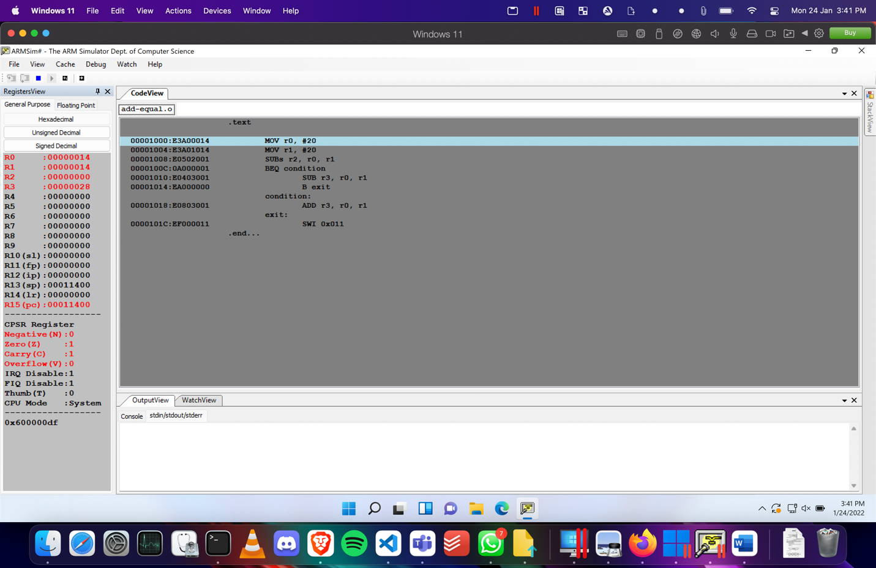

Subtact:

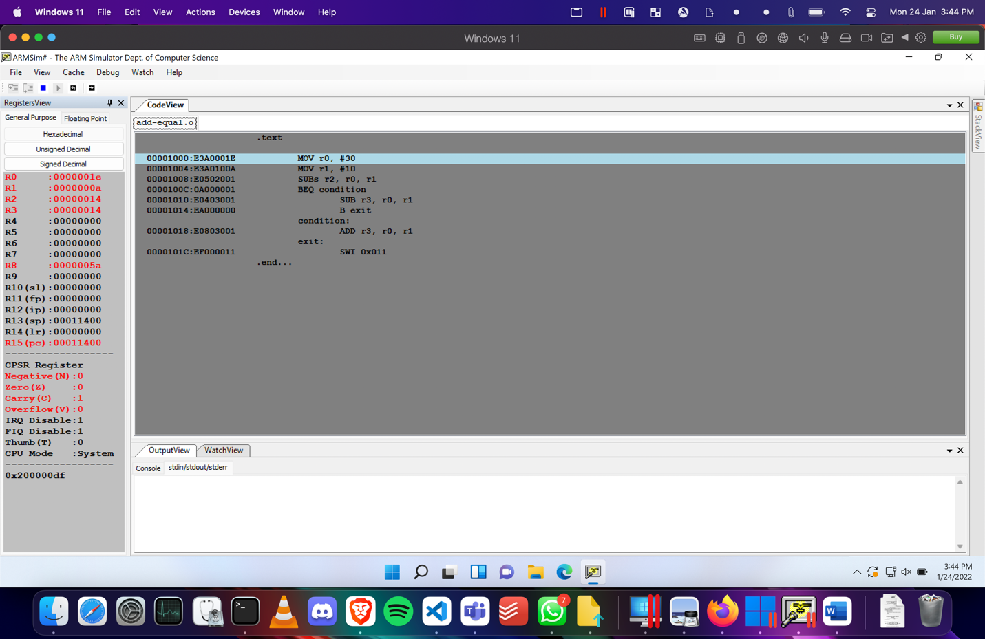

1. Output table (1)

**Included in above screenshots**

**Disclaimer:**

* The programs and output submitted is duly written, verified and executed by me.
* I have not copied from any of my peers nor from the external resource such as internet.
* If found plagiarized, I will abide with the disciplinary action of the University.

Signature:Naman Choudhary

Name:Naman Choudhary

SRN:PES2UG20CS209

Section: D

Date:24/01/2022